Standard Operating Procedure

*Changing Pod Replicas and Autoscaling Pod Counts*

## PURPOSE

The purpose of this standard operating procedure (SOP) is to provide a detailed step-by-step procedure to change pod replicas and autoscaling pod counts. **In Prod environments, perform this SOP only when instructed.**

## PROCEDURE

First, check quotas to make sure there is room to increase pod replicas. Changing pod replicas and autoscaling pod counts can be done on either OSE console or on the terminal. Double check to be the correct project and correct environment.

**On the Console – Change Pod Replicas (Option 1)**

1. Click on “Overview” tab on the left of the page, which leads to the overview page:

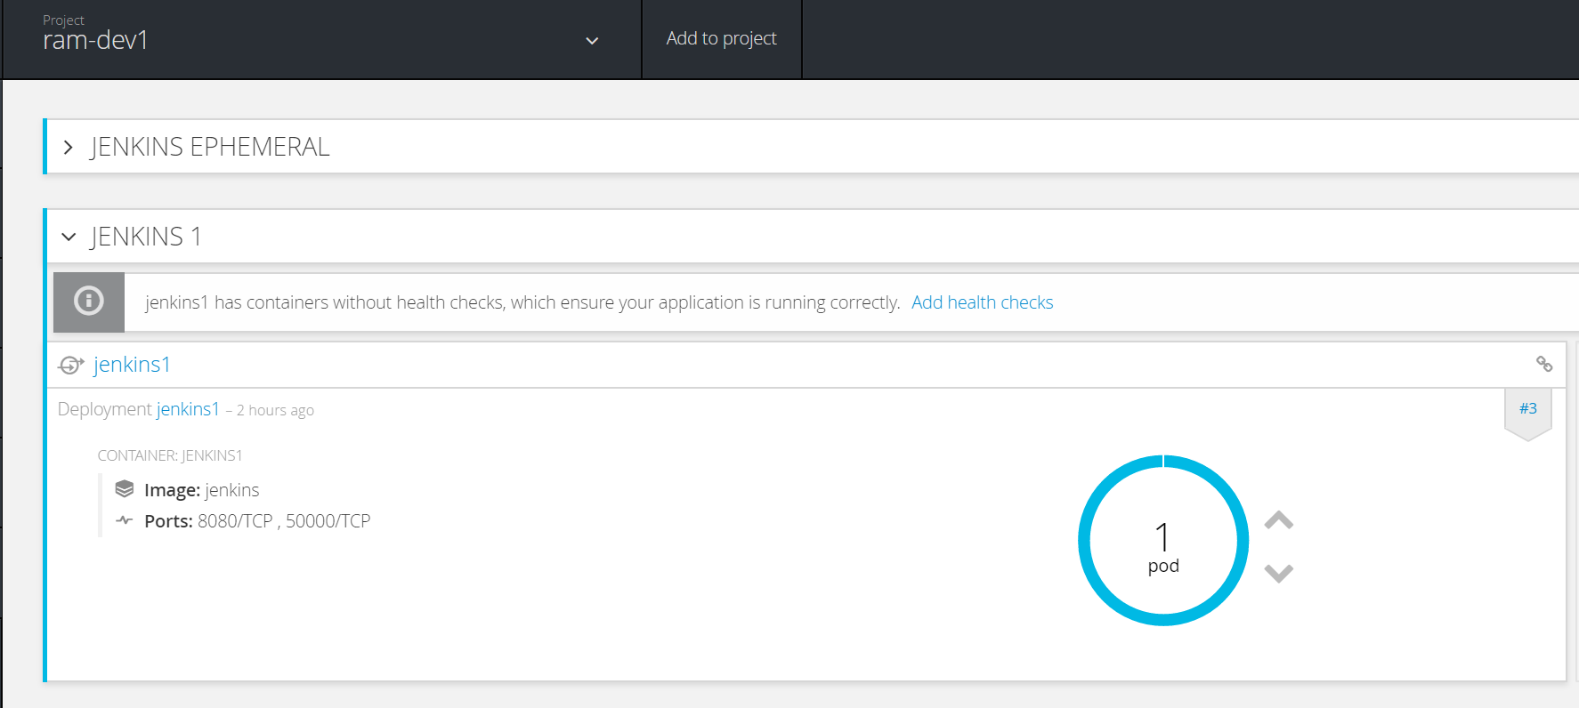

Click on the up arrow (in green rectangle) to increase, down arrow to decrease:

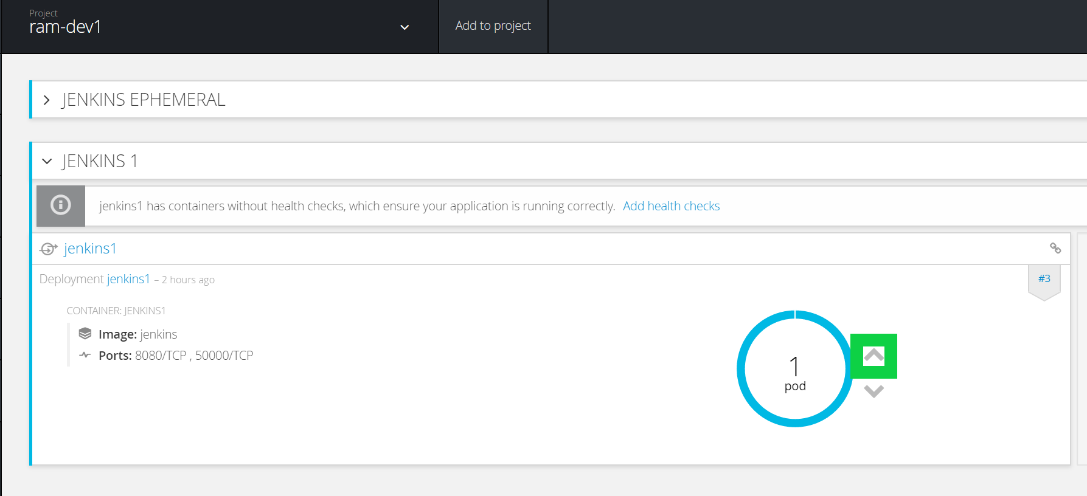

Verify that the number of pods has increased by looking at the count (in green rectangle):

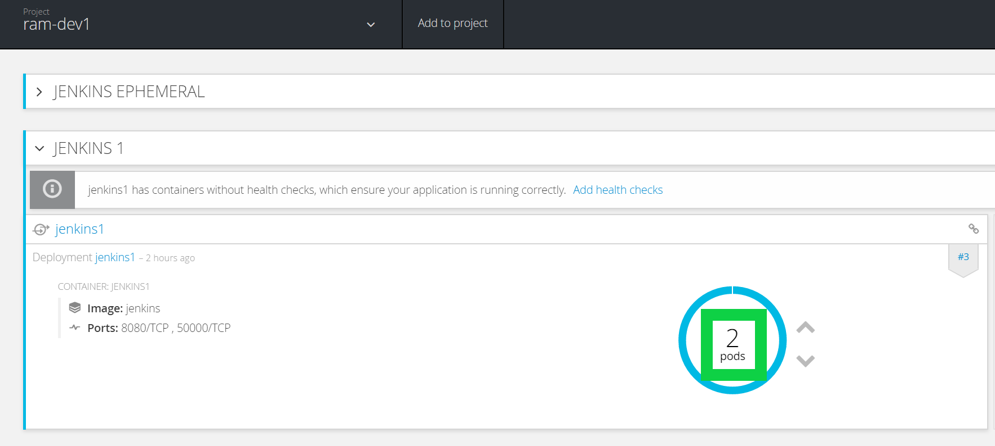

**On the Console – Change Pod Replicas (Option 2)**

1. Click on “Application” tab on the left of the page, and click on “Deployments”: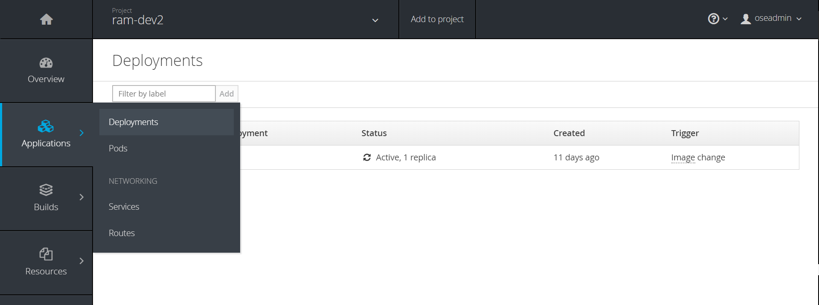

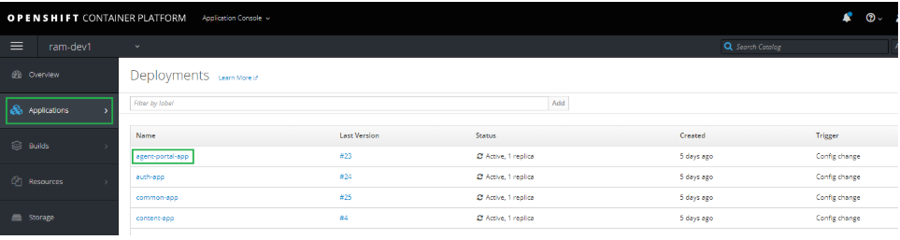

Click on the Deployment name:

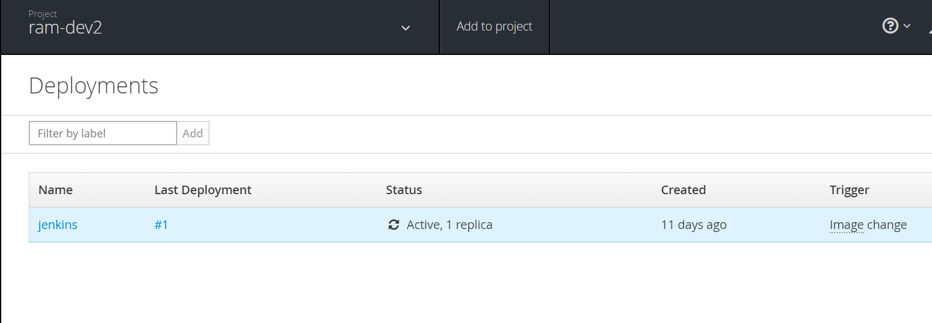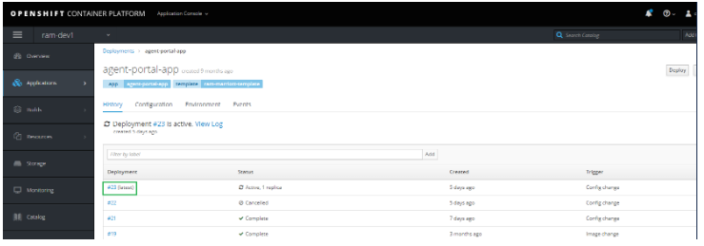

Click on the pencil icon next to Replicas under Configuration and change the value:

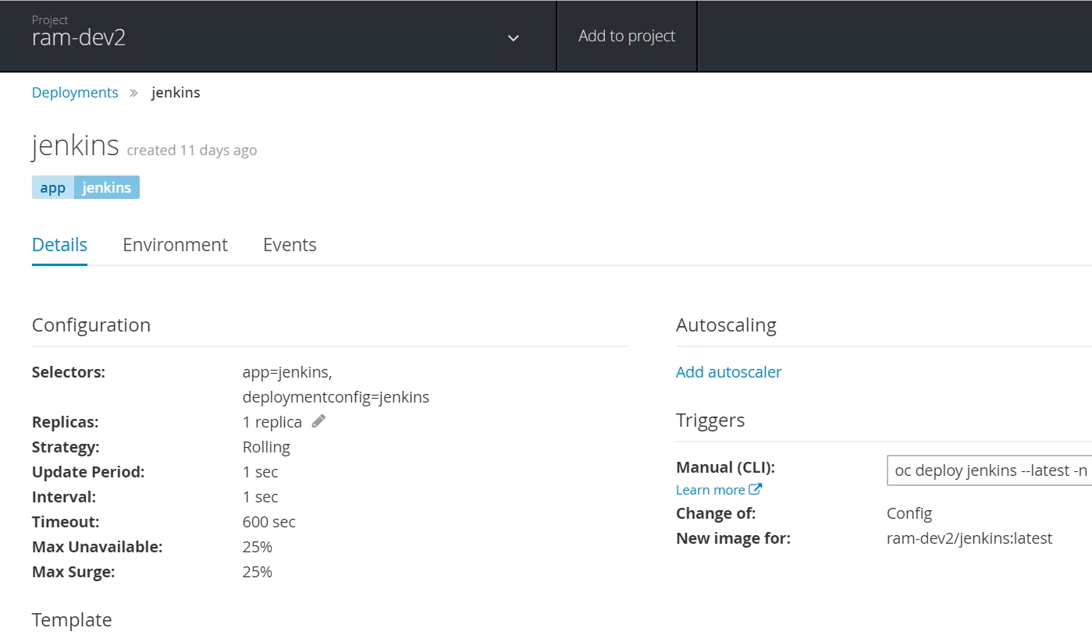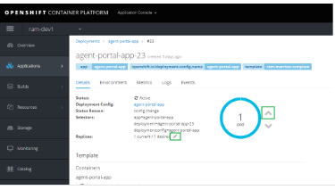

**On the Console – Change Autoscaling Pod Counts**

1. Click on the Project to be modified (e.g., ambassador-prod1):

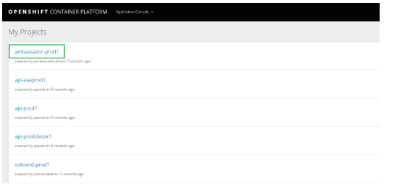

1. Select the **Overview** tab on the left of the screen and then Revision number for the APP to be updated. In this example we are selecting the consumer-events APP Revision #4.

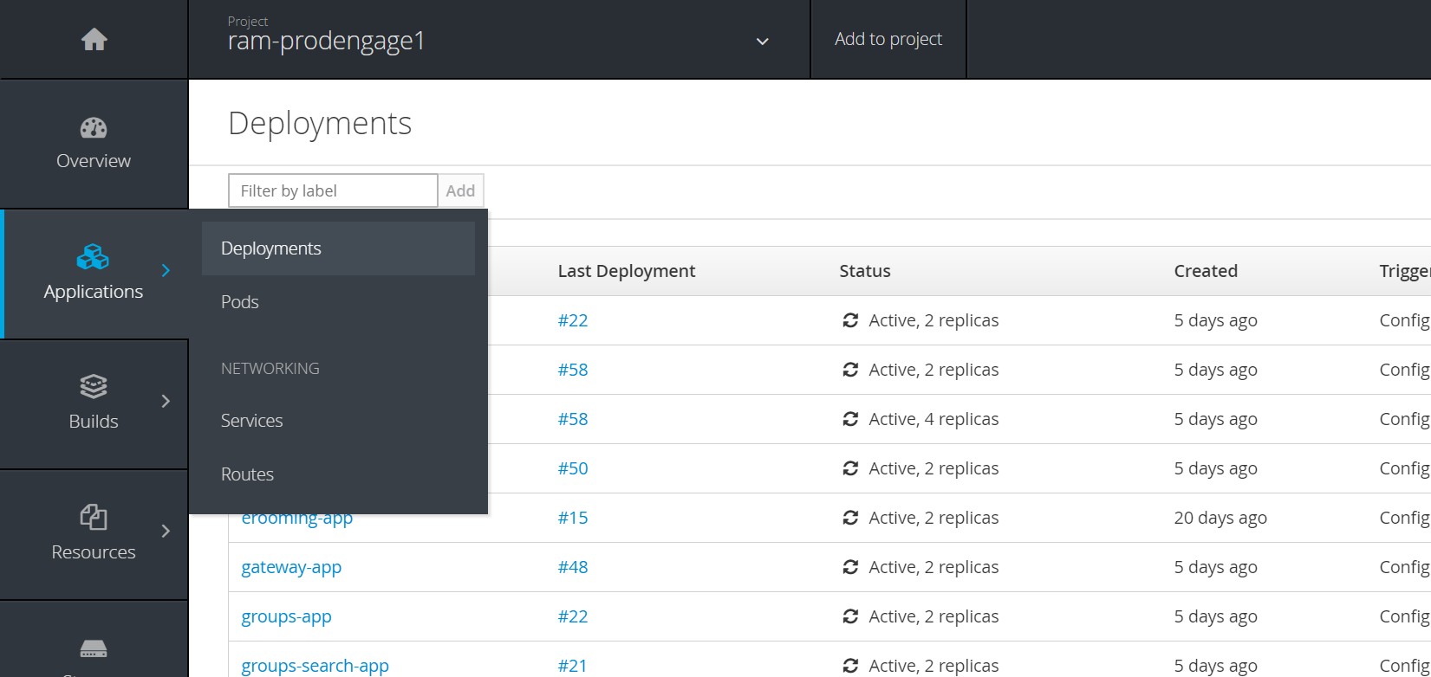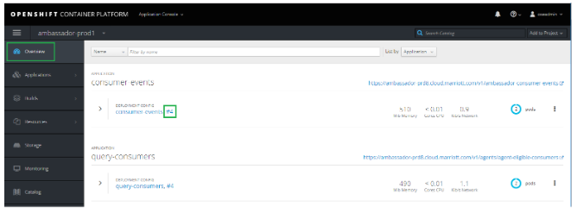

The Deployment screen for the APP (e.g., consumer-events-4) will appear.

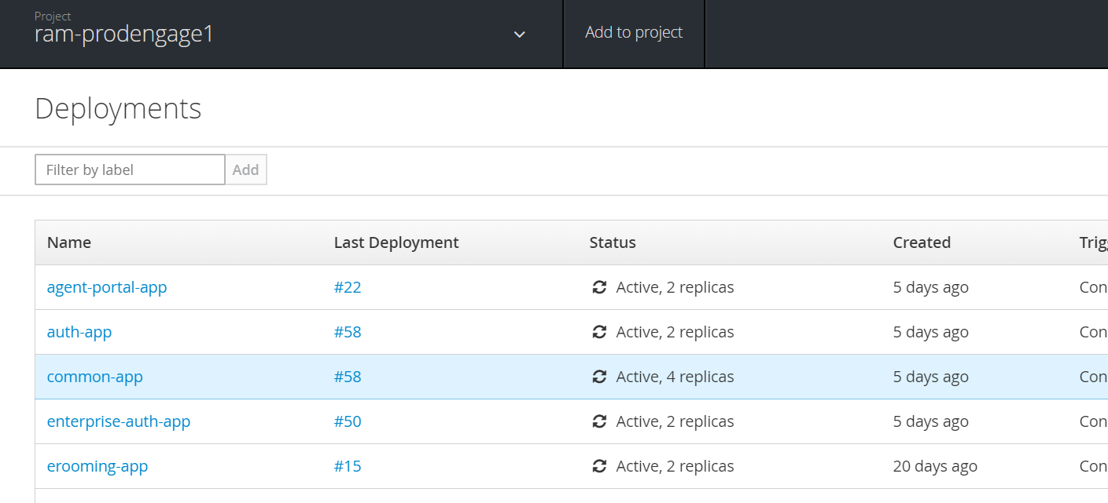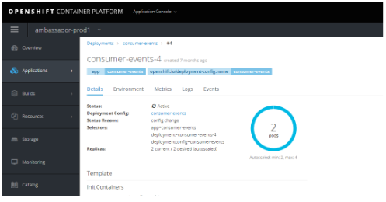

Scroll to the bottom on this Deployments screen to access the Autoscaling Section of the Deployment. Select the EDIT button within the Autoscaling Section.

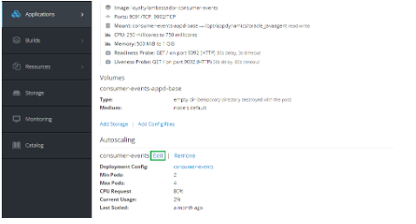

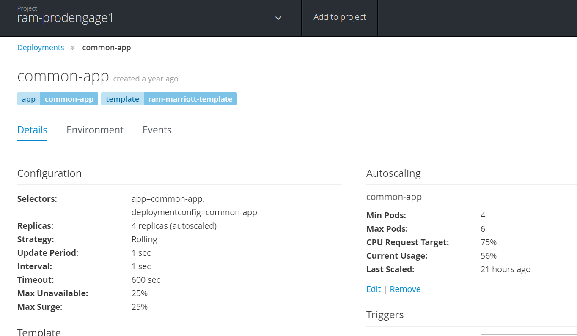

Update the **Min Pods,** **Max Pods**, and/or **CPU Request Target** and then click the **SAVE** button.

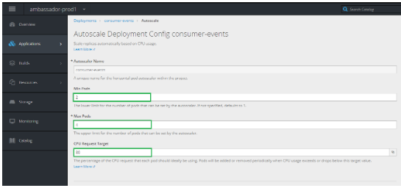

**On the Terminal – Change Pod Replicas**

1. Go to the correct project:

oc project <project name>

i.e.

[root@master01-devtest-vxbyb ~]# oc project ram-dev1

Already on project "ram-dev1" on server "https://ose-devtest-vxbyb.marriott.com:8443".

Get dc of the deployment pods:

oc get dc | grep <deployment name>

(The last single number represents current count of the pod)

i.e.

[root@master01-devtest-vxbyb ~]# oc get dc | grep jenkins1

jenkins1 3 1 1 config,image(jenkins1:latest)

Scale the pod:

oc scale dc jenkins1 --replicas=<number of replicas>

i.e.

[root@master01-devtest-vxbyb ~]# oc scale dc jenkins1 --replicas=2

deploymentconfig "jenkins1" scaled

Verify that the number of pods has increased:

oc get dc | grep <deployment name>

i.e.

[root@master01-devtest-vxbyb ~]# oc get dc | grep jenkins1

jenkins1 3 2 2 config,image(jenkins1:latest)

## VALIDATION

Follow the validation steps in “Procedure”.

**Document Version Control**

|  |  |  |  |
| --- | --- | --- | --- |
| Version | Effective Date | Reviewed by | Approved by |
| 1.0 | 1/24/2019 | KyungIn Kim | Yashi Kumar |
|  |  |  |  |

Document Modification History & Revision Log

|  |  |  |  |  |  |  |
| --- | --- | --- | --- | --- | --- | --- |
| Version | Date Modified | Revised by | Role | Section Affected | Reference | Remarks |
| 1.0 |  |  |  |  |  |  |
| 1.1 |  |  |  |  |  |  |